The Gainesville Harmony Show Chorus
Newsletter January 2017

The 2015-2016 period was a memorable time for the chorus. We continued to sing monthly at the Naturalization Ceremonies. There were more ceremonies in 2016 because there was a push to get more new citizens ready to vote in the presidential election.
We won first place in the small chorus division and 5th place overall in our regional competitions in 2015 and 2016. Since we were one of the five top scoring small choruses in Sweet Adelines International, we qualified to attend the Harmony Classic Competition in Las Vegas in October 2016. The Harmony Classic Competition brings the top five small- (30 and under) and medium-sized (31-60) choruses from all over the world to compete against each other. Once we qualified we spent a lot of time working on the package we would present in Las Vegas and figuring out ways to earn enough money to help all our members make the trip.
Thanks to our sponsors and the support of Coastal Harmony Region 9 and our local community for our various fund-raising activities, we were able to take 26 members to Las Vegas for this competition. It was a little intimidating to sing in the huge MGM Grand auditorium, but it was certainly an amazing experience. We ended up placing 5th in the Division A category against some very good choruses.
During our preparation for International we were fortunate to have had a number of excellent coaches work with us, including Karen Breidert and Jim Arns. And now in the words of some of our members:
The iPad Raffle and Shipping Costumes and Props—Joan Gowan
International Competition was exciting; it was fun; it was very expensive. Without the support of our generous sponsors, The Barbergators, our families and friends, and yes, a myriad of fundraisers, there’s no way we could have taken 26 singers to Las Vegas for a week. But fundraisers can surprise, and our nearly year-long raffle of a beautiful gold iPad Mini certainly surprised me at the very last moment.
We had set up the rules from the beginning in order to make it fair to all ticket purchasers. No one in the chorus or in their immediate household could win. We could, and did, sell to other members of our families, to friends, to audience members, and to other chorus women around our region. I supported the raffle by buying a ticket for each of my grandchildren. The drawing was to be at our very last performance before departing for Vegas.
The big night arrived. 600 blue tickets were all mixed up in a cut glass urn. I stood in front of our audience at The Village and asked for volunteers to help with the drawing. Three hands in the back row shot up as arranged and as the children came forward I commented, “These are my grandchildren. It looks like a set-up, doesn’t it?” (Chuckles from the audience.) The urn was heavy so Rachel (14) held it, Sam (12) took the lid and Charlie (7) dipped her hand in, stirred it about and pulled a ticket. As she handed me the ticket I got a quick glimpse of the name—Charlie had pulled the 1 ticket of 600 with her own name on it! I won’t repeat the word that hit my brain: I mean, what are the odds and after my “set-up” comment, how would it look? I had about a frantic one second to decide. “Oh, Charlie, that’s not a good ticket. Pick another.” To her credit, she didn’t cry or complain and a member of the audience won. Note: I replaced my own iPad Mini in December and Charlie got my old one in a shiny new purple case marked with her initials for Christmas.
The logistics of getting the chorus to Las Vegas was a challenge. We were going to International Competition as one of the top 5 small barbershop choruses in Sweet Adelines International. We were 26 singers leaving for Las Vegas from three airports on at least 5 flights over two days—what could possibly go wrong? Well, an airline lost all the props belonging to a New Zealand chorus a year or so ago; so we thought perhaps we should ship our props and costumes via UPS.
We were super organized. We presented our competition package to Family and Friends on Tuesday, October 4. On Thursday, October 6, each of us brought her costume in three gallon-size zip-lock bags, clearly marked with names. The costumer (that’s me) and Diane and Chanda, the directors, planned to pack the costumes and props on Friday and take them to UPS, giving them 10 days to arrive in Vegas. It all would have worked perfectly except for Hurricane Matthew. He blew through Gainesville Friday and closed all shipping in and out of Florida. The UPS office opened Saturday, but by that time they couldn’t guarantee ground delivery until the day before our performance—much too late for both rehearsals and our peace of mind. However, second-day air….
Now, please picture 78 slippery gallon bags filled with glittery costumes, three large signs, a whole bunch of bags, boxes, curtain rods, draperies, two wigs and a four-foot ice cream cone. It took eight boxes to contain it all and eight boxes sent second-day air cost over $800—much, much more than we had planned. But all eight did arrive at the MGM Grand. We got there several days later and went to pick them up. “We’ll deliver them for $155,” we are told. Couldn’t we just get a luggage cart and haul them ourselves? “We don’t do that here.” Sigh!
We just had three boxes going home and ground service was just fine. We carried them to the office ourselves and paid the much more reasonable shipping fees, oh and another $77 handling fee to the hotel. Next time we may take our chances on the airlines!
Annie Harvey
Our trip to Las Vegas to participate in the Sweet Adelines International Harmony Classic Competition was a wonderful experience. As a new member in the Gainesville Harmony Show Chorus but a long-time member of Sweet Adelines, I was very excited to be a part of the first-place award winning small chorus in our region and be invited to international competition. All of the planning, rehearsing and fund raising was an exhilarating part of the excitement.
Even though Las Vegas has a lot of entertainment, fun and games, there really was no time for the casinos. I was consumed with the SAI program of chorus and quartet competitions, the educational workshops, as well as the showcase of large chorus champions and quartet queens of harmony adorned with crowns. The competitions were mesmerizing and included member groups from across the United States and as near as Canada and as far away as New Zealand displaying varying styles of costumes and cultural traditions.
The trip provided the opportunity to share with new acquaintances a little of the life in the Gainesville area and experience the laughter and exhilaration of being with singers and dancers like ourselves. Above all, I was deeply moved by SAI’s recognition of its 50-year commitment to diversity and inclusion and to see up close this worldwide organization of women advancing the music art form of barbershop harmony through education, competition and performance. Although the time passed quickly and it was over way too soon, the harmony and melodies linger on.
Cassandra Holloway
Oh my goodness, where to start talking about my experience at Sweet Adelines International Harmony Classic Competition in Las Vegas! It is always an honor to be with the amazing group of women that make up the Gainesville Harmony Show Chorus. They are truly some of my most favorite people in the world! Now, times that feeling of pride by the thousands and you get an idea of what it was like to share the stage with the talented women from all across the world. It was AWESOME!!
It was my immense privilege to have one of the speaking parts in our performance package. I found the prospect both exhilarating and terrifying. For the 6 months preparing for the competition I was concerned about how I would do and wanting to represent the chorus well. We would be competing in the biggest venue I have ever been in not to mention the largest audience ever.
I was a basket of nerves all the way to stage. I walked up the ramp leading to the stage, focusing on my breathing and praying I would not fall on my face, but the moment I passed the curtain on the stage, everything settled. This was where I belonged. It was fantastic and exciting. I was especially blessed to have three members of my family in the audience. My grandma (a former Sweet Adeline), my mom and my stepmom were all able to come down from the Pacific Northwest. What a way to experience my first international competition!
Kitty Lehtola
What happens in Vegas, stays in Vegas – or so the saying goes. But there are always exceptions to any rule. What happened in Vegas in October of 2016 will be shared and mulled over by the members of the Gainesville Harmony Show Chorus for years to come. But our experience actually started way before Vegas. It actually started 19 months ago when we received the news—Gainesville Harmony Show Chorus qualified for International competition in Las Vegas, Nevada. After the initial celebration, serious fundraising commenced. Thanks to our wonderful sponsors, friends, families and patrons, we were on our way!
Early days and late nights were our reality for the 7 days we were there. But those 7 days were fantastic and not too many of us would trade all those activities for more sleep. Even crowded airplanes were not enough to dampen our excitement. Those 7 days were full of barbershop music, friendships renewed, rehearsals, barbershop music, lots of walking, and – oh yes, did I mention the music! We were able to see the best of the best from all over the world—the Japanese chorus in their kimonos, the amazingly friendly Aussies, the TALL Swedes, etc. At some point we met them all—in restaurants, in the elevators, in the convention center and in competition. We were entertained by and amazed by large choruses, mid-sized choruses, small choruses and quartets—and so proud to be worthy to be part of it. We headed home at the end, tired, carrying souvenirs, a few extra pounds and best of all, new jewelry—our medal.
Donna Martin
They say what happens in Vegas stays in Vegas. But what I saw at the Sweet Adelines International Convention in Vegas will stay with me for a very long time; and I want to share the joy with everyone.
I joined the Gainesville Harmony Show Chorus just over a year ago, and right away the ladies started talking about the upcoming trip to Las Vegas, since they had qualified to compete in the Sweet Adelines International Harmony Classic Competition. I was hooked!
I saw thousands of women standing in front of that huge audience in the MGM Grand Convention Center, performing at the highest level, some wearing beautiful gowns, some wearing ridiculous-looking outfits (who wants to look like a bumblebee?). But what I heard were their beautiful voices, and what I saw was their camaraderie, self-confidence, creativity, and competitive spirit as each one performed at her personal best to garner success for her team.
The choreography was amazing. I wondered, “How many hours must it have taken for them to perform their 15-minute package with such perfectly coordinated group movements/” Several of those choruses had well over one hundred members—if they made mistakes, I did not notice.
Being there gave me a much better understanding of what it takes to be a part of a championship chorus. The first-place large chorus was from Sweden. They sang in English and had better pronunciation and word synchronization than those of us who are native English speakers. How does that happen?
As Sweet Adelines, we don’t just raise our voices in song! We raise our expectations of ourselves; we raise our skill level of performance; and we raise a banner of appreciation for all who work so hard to produce a winning chorus.
Diane Sherley—What Sweet Adelines Means to Me
Thinking about this past year, I am filled with feelings of pride, love, gratitude and honor. The Las Vegas experience was truly awesome. All the hard work and the many hours of preparation were worth the experience we had as a chorus. I am proud of all that the chorus accomplished this past year, and I’m not just talking about musically. The way the whole chorus pulled together to find ways to make sure each and every chorus member had the funds to go on this wonderful adventure together was truly inspiring.
I have been involved with barbershop since I was about seven years old. My father sang with a barbershop chorus in Indiana. Soon after he joined a chorus, he was in a quartet. I loved the sounds the four human voices could produce and I fell in love with the barbershop style of singing. When Jim and Grace Northrup decided to start a Sweet Adelines chorus in Gainesville, I was thrilled to be a part of this new adventure in my life. After all it was only going to be one night a week!
I soon found out that if you truly loved it, one night a week was not enough. Being a part of this chorus has meant so much to me. When the chorus asked Beth Ripple and me to become co-directors, I was so honored that they would trust me with such a huge responsibility. And I have tried to make sure that I learned as much as I could to help the chorus grow and improve our love of the barbershop craft.
The chorus has seen me through a divorce, raising my kids, getting married again, family ups and downs, and the death of both my parents. There is no better support system than your Sweet Adeline sisters. No words can express the gratitude I have for my chorus and all the support they have given me.
Being a part of a Sweet Adeline chorus is not a hobby to me. It is a way of life, which I truly love and would not give up unless I just had to. The chance to sing with friends every week, to me, is truly a gift that I treasure. Here’s to Sweet Adelines everywhere. They are all awesome!
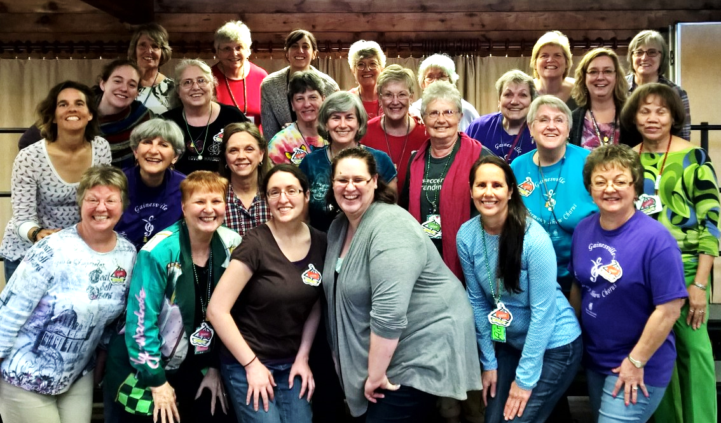

Do you love to sing? Come visit and see if this is something you would like to do. We rehearse Thursdays at 7:00 pm.
Grace Presbyterian Church
3146 SW 13th Street, Gainesville, FL
Contact: Beth Ripple
(352) 870-5555

